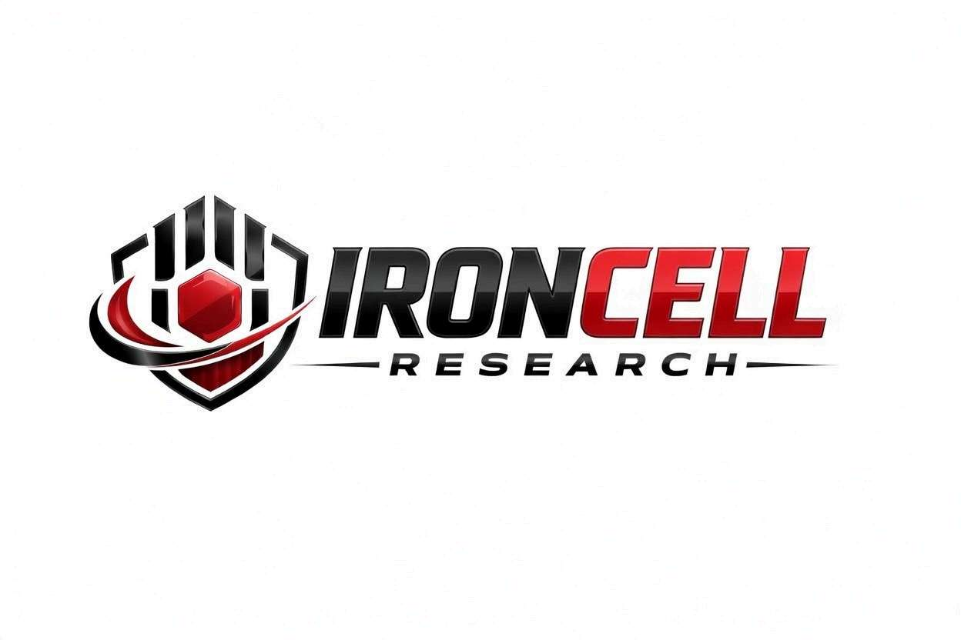
PEPTIDE RESEARCH BRIEF
BPC-157 / TB-500
Regenerative Blend | Body Protection Compound + Thymosin Beta-4 Fragment

Description, Benefits, Dosage & Research Overview

Iron Cell Research
IronCellResearch.com
For Research Use Only


Blend Overview
Blend Name | BPC-157 / TB-500
Classification | Regenerative Peptide Blend
Components | BPC-157 (Body Protection Compound) + TB-500 (Thymosin Beta-4 Fragment)
Research Focus | Tissue repair, recovery, anti-inflammatory
Purity | Greater than or equal to 99% (each component)
Storage | Lyophilized, -20C, protected from light
Research Status | Active preclinical research (individual and combined)

Description
This blend combines two of the most researched regenerative peptides. BPC-157 is a pentadecapeptide (15 amino acids) derived from human gastric juice, known for its powerful tissue-protective and healing properties. TB-500 is the active fragment (amino acids 17-23) of Thymosin Beta-4, a 43-amino acid protein involved in cell migration and tissue repair.
Together, these peptides provide complementary mechanisms of tissue repair, offering broader regenerative coverage than either peptide alone.

Component 1: BPC-157
Full Name | Body Protection Compound-157
Sequence | Gly-Glu-Pro-Pro-Pro-Gly-Lys-Pro-Ala-Asp-Asp-Ala-Gly-Leu-Val
Molecular Weight | 1419.53 g/mol
CAS Number | 137525-51-0
Origin | Derived from human gastric juice
Stability | Stable in gastric juice (unique among peptides)

BPC-157 Mechanisms
BPC-157 promotes angiogenesis through upregulation of VEGF and FGF-2, modulates the nitric oxide (NO) system for vascular and tissue protection, upregulates growth factor receptors including EGF and HGF, and directly stimulates tendon fibroblast outgrowth for tendon and ligament healing.

Component 2: TB-500
Full Name | Thymosin Beta-4 Fragment (amino acids 17-23)
Sequence | LKKTETQ
Molecular Weight | 846.93 g/mol
Origin | Active fragment of Thymosin Beta-4
Biological Half-Life | Approximately 2 hours

TB-500 Mechanisms
TB-500 sequesters G-actin monomers to promote cell migration and tissue repair, reduces inflammation through downregulation of pro-inflammatory cytokines, promotes angiogenesis and new blood vessel formation, and activates hair follicle stem cell migration for wound healing.

Synergistic Research Benefits

Musculoskeletal Recovery
- Tendon & Ligament: BPC-157 stimulates fibroblast outgrowth while TB-500 promotes cell migration to injury sites, providing comprehensive connective tissue repair.
- Joint Health: Combined anti-inflammatory and regenerative effects support cartilage and synovial tissue healing.
- Bone Healing: Complementary angiogenic and growth factor pathways may support fracture repair.

Soft Tissue Repair
- Muscle Recovery: TB-500 promotes myocyte migration and differentiation while BPC-157 enhances blood vessel formation for nutrient delivery to damaged muscle.
- Wound Healing: Dual angiogenic pathways accelerate wound closure and tissue remodeling.

Gastrointestinal Health
- Gut Protection: BPC-157 demonstrates potent gastroprotective properties unique among peptides, protecting against ulcers, inflammatory bowel conditions, and gut barrier dysfunction.
- Mucosal Healing: Combined effects support intestinal mucosal integrity and repair.

Cardiovascular Support
- Vascular Repair: Both peptides promote angiogenesis through distinct pathways, providing enhanced blood vessel formation and repair.
- Cardioprotection: BPC-157 has shown protective effects in cardiac injury models through NO pathway modulation.

Dosage & Administration
The following dosage information is provided for research reference purposes only. Components may be administered separately or in combination.
Protocol | Dose Range | Route | Frequency
BPC-157 Standard | 250-500 mcg | SubQ Injection | Daily
BPC-157 Maintenance | 250 mcg | SubQ Injection | Daily
TB-500 Loading | 2-5 mg | SubQ Injection | 2x per week (4-6 weeks)
TB-500 Maintenance | 2 mg | SubQ Injection | 2x per month

Reconstitution Guidelines
Solvent | Sterile bacteriostatic water
BPC-157 Reconstitution | 1-2 mL BAC water per vial
TB-500 Reconstitution | 1-2 mL BAC water per vial
Mixing | Gently swirl each vial, do not shake
Storage | Refrigerate at 2-8C, use within 21 days
Injection Site | Subcutaneous, rotate sites, may inject near injury site

Safety Profile
Both components demonstrate favorable safety profiles in preclinical research:
- BPC-157 Tolerability: Excellent safety profile in animal studies with no reported toxic dose identified. As a gastric peptide fragment, it is well-tolerated across multiple routes of administration.
- TB-500 Tolerability: Derived from naturally occurring Thymosin Beta-4, TB-500 shows good tolerability with minimal adverse effects in preclinical models.
- Injection Site Reactions: Mild, transient redness or discomfort possible with subcutaneous injection for either component.
- Drug Interactions: No significant drug interactions identified for either component in preclinical research.
- Pregnancy & Nursing: Insufficient safety data; use not recommended during pregnancy or lactation.
Long-term human safety data remains limited for both peptides. Research continues to establish comprehensive safety profiles.

Key References
- Seiwerth S, et al. BPC 157 and Standard Angiogenic Growth Factors: Gastrointestinal Tract Healing, Lessons from Tendon, Ligament, Muscle and Bone Healing. Current Pharmaceutical Design. 2018.
- Chang CH, et al. The Promoting Effect of Pentadecapeptide BPC 157 on Tendon Healing Involves Tendon Outgrowth, Cell Survival, and Cell Migration. Journal of Pharmacological Sciences. 2011.
- Pevec D, et al. Impact of Pentadecapeptide BPC 157 on Muscle Healing Impaired by Systemic Corticosteroid Application. Medical Science Monitor. 2010.
- Huff T, et al. Beta-Thymosins, Small Acidic Peptides with Multiple Functions. International Journal of Biochemistry & Cell Biology. 2001.
- Goldstein AL, et al. Thymosin Beta-4: A Multi-Functional Regenerative Peptide. Expert Opinion on Biological Therapy. 2012.
- Malinda KM, et al. Thymosin Beta-4 Accelerates Wound Healing. Journal of Investigative Dermatology. 1999.
- Sosne G, et al. Thymosin Beta-4 and the Eye: Current Research and Clinical Applications. Expert Opinion on Biological Therapy. 2016.
- Smart N, et al. Thymosin Beta-4 Is Essential for Coronary Vessel Development. Annals of the New York Academy of Sciences. 2007.

Contact & Information
Company | Iron Cell Research
Website | IronCellResearch.com
Email | orders@ironcellresearch.com
Product Support | Available via website contact form

Disclaimer
This document is intended for informational and research purposes only. BPC-157 / TB-500 is sold as a research compound and is not intended for human consumption. The information provided herein does not constitute medical advice, diagnosis, or treatment recommendations. All research applications should comply with applicable institutional, local, and federal regulations. Iron Cell Research makes no claims regarding the therapeutic efficacy of BPC-157 / TB-500 for any medical condition. Researchers should consult with qualified healthcare professionals and institutional review boards before initiating any research protocols involving human subjects.
Iron Cell Research - For Research Use Only


